1. **In order to use an image taken from the newspaper (no copy rights before 1960) use snipping tool to take image. Then upload image to google Drive. There is folder already created for images. Save the image using the name of the Newspaper (With the city inside the parenthesis)**
2. **Then get the link for the image by clicking on sharing https://drive.google.com/uc?id=1VfPERLN7GFtHnlBi5KVqZYjKyJcrcYfA**

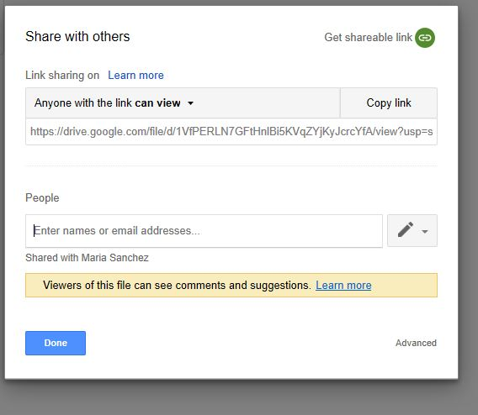

**3.**

https://drive.google.com/file/d/**1VfPERLN7GFtHnlBi5KVqZYjKyJcrcYfA**/view?usp=sharing

Then copy ID number Found in Bold in above and add it to the following link:

[https://drive.google.com/uc?id=](https://drive.google.com/uc?id=18u41M8hcZiv3IG1yeZnB5A-pG_U0Udui)**1VfPERLN7GFtHnlBi5KVqZYjKyJcrcYfA**

Example:

<https://drive.google.com/uc?id=1VfPERLN7GFtHnlBi5KVqZYjKyJcrcYfA>

MAP LINK

<https://gbventura.github.io/Hispanic_Periodicals/>

No Image Available image link

[https://drive.google.com/uc?id=](https://drive.google.com/uc?id=18u41M8hcZiv3IG1yeZnB5A-pG_U0Udui)1jm6Mq-MmqC4LX6xcAHEXNYFkAOaE-bsx

**Notes for Map Protocols:**

Visual Bibliography of Hispanic Periodicals in the United States: Origins to 1960

This map was created by Recovering the US Hispanic Literary Heritage based on the book <i>Hispanic Periodicals in the United States: Origins to 1960 A Brief HIstory and Comprehensive Bibliography</i> by Nicolás Kanellos and Helvetia Martell. The purpose of this visualization is to reveal the written legacy of US Latinos in serial publication form and creating awareness of the historical extent to which the latino community has made their presence in the United States.

**Questions/Concerns for future of project:**

1. **We need to double check our info with that of OCLC for updates.**
2. **Should we add OCLC number for those interested in Newspaper?**